

Change Management Process©
For [Project Name]

Document Control

Document Information
© | Information
Document Id | [Document Management System #]
Document Owner | [Owner Name]
Issue Date | [Date]
Last Saved Date | [Date]
File Name | [Name]

Document History
Version | Issue Date | Changes
[1.0] | [Date] | [Section, Page(s) and Text Revised]

Document Approvals
Role | Name | Signature© | Date
Project Sponsor

Project Review Group

Project Manager

Quality Manager
(if applicable)

Procurement Manager
(if applicable)

Communications Manager
(if applicable)

Project Office Manager
(if applicable)

Table of Contents

1 Change Process 2
1.1 Overview 2
1.2 Submit Change Request 4
1.3 Review Change Request 4
1.4 Identify Change Feasibility 4
1.5 Approve Change Request 5
1.6 Implement Change Request 5
2 Change Roles 5
2.1 Change Requester 5
2.2 Change Manager 6
2.3 Change Feasibility Group 6
2.4 Change Approval Group 6
2.5 Change Implementation Group 6
3 Change Documents 7
3.1 Change Register 7
3.2 Change Request Form 7

Template Guide

What is a Change Management Process?

A Change Management Process is a method by which changes to the project (e.g. to the scope, deliverables, timescales or resources) are formally defined, evaluated and approved prior to implementation. The process entails completing a variety of control procedures to ensure that, if implemented, the change will cause minimal impact to the objectives of the project.

A Change Management Process is used to ensure that every change identified is formally:

- Communicated
- Documented
- Reviewed
- Approved
- Implemented. ©

When to use a Change Management Process

The Change Management Process is undertaken during the ‘Execution’ phase of the project (i.e. the phase within which the deliverables are produced), once the project has been formally defined and planned. In theory, any change to the project during the Execution phase will need to be formally managed as part of the Change Management Process. Without a formal Change Management Process in place, the objective of delivering a solution within ‘time, cost and quality’ may be compromised. ©

The Change Management Process is terminated only when the Execution phase of the project is completed (i.e. just prior to Project Closure).

How to use this template

This document provides a guide on the topics usually included in a Change Management Process document. Sections may be added, removed or redefined at your leisure to meet your particular business circumstance. Example tables, diagrams and charts have been added (where suitable) to provide further guidance on how to complete each relevant section.

Change Process

Overview
Provide an overview of the Change Management Process. For example:

The Change Management Process is undertaken to ensure that each change introduced to the project environment is appropriately defined, evaluated and approved prior to implementation.

Change Management will be introduced to this project through the implementation of five key processes:

- The submission and receipt of change requests
- The review and logging of change requests
- The determination of the feasibility of change requests
- The approval of change requests
- The implementation and closure of change requests. ©

The following diagram describes the processes and procedures to be undertaken to initiate, implement and review the effects of changes within the project. Where applicable, Change Roles have also been identified:

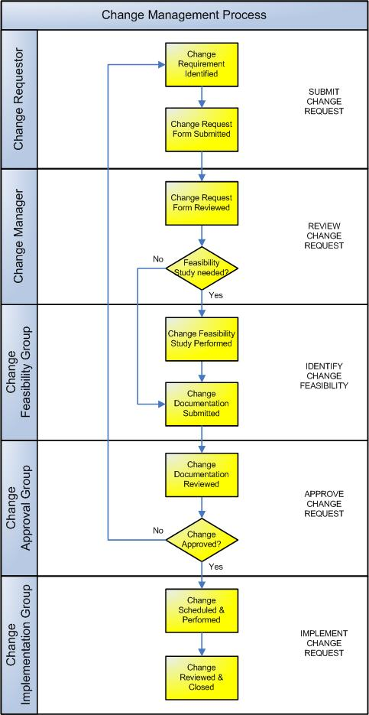

Submit Change Request
This process provides the ability for any member of the project team to submit a request for a change to the project. The following procedures are completed:

Change Requester:

- Identifies a requirement for change to any aspect of the project (e.g. scope, deliverables, timescales and organization) ©
- Completes a Change Request Form (CRF) and distributes the form to the Change Manager. The CRF summarizes the change:

  - Description
  - Reasons
  - Benefits
  - Costs
  - Impacts
  - Approvals.

Review Change Request
The Change Manager reviews the CRF and determines whether or not a full Feasibility Study is required for the Change Approval Group to assess the full impact of the change. The decision will be based primarily on the:

- Number of change options presented
- Complexity of the change options requested
- Scale of the change solutions proposed. ©

The Change Manager will record the CRF details in the Change Register and decide whether or not a change Feasibility Study is required.

Identify Change Feasibility
A Feasibility Study is completed (if required) to determine the extent to which the change requested is actually feasible. The change Feasibility Study will define in detail the change:

- Requirements
- Options
- Costs and benefits
- Risks and issues
- Impact
- Recommendations and plan.

All change documentation is then collated by the Change Manager and submitted to the Change Approval Group for final review. This includes:

- The original CRF
- The approved Change Feasibility Study report
- Any supporting documentation.

Approve Change Request
A formal review of the CRF is undertaken by the Change Approval Group. The Change Approval Group will choose one of the following outcomes regarding the change proposed:

- Reject the change
- Request more information related to the change
- Approve the change as requested
- Approve the change subject to specified conditions. ©

The decision will be based primarily on the following criteria:

- Risk to the project in implementing the change
- Risk to the project in NOT implementing the change
- Impact on the project in implementing the change (time, resources, finance, quality).

Implement Change Request
The approved change is then implemented. This includes:

- Identifying the date for implementation of the change
- Testing the change prior to implementation
- Implementing the change
- Reviewing the success of the change implementation
- Communicating the success of the change implementation
- Closing the change in the change log.

Change Roles
Define the roles and responsibilities for all resources (both within and external to the project) involved with the initiation, review and implementation of changes within the project. For example:

Change Requester
The Change Requester initially recognizes a need for change to the project and formally communicates this requirement to the Change Manager. The Change Requester is responsible for:

- Identifying the requirement to make a change to the project
- Documenting the requirement by completing a CRF
- Submitting the CRF to the Change Manager for review. ©

Change Manager
The Change Manager receives, logs, monitors and controls the progress of all changes within a project. The Change Manager is responsible for:

- Receiving all CRFs and logging them in the Change Register
- Categorizing and prioritizing all CRF
- Reviewing all CRFs to determine whether additional information is required
- Determining whether or not a formal change Feasibility Study is required
- Forwarding the CRF to the Change Approval Group for approval
- Escalating all CRF issues and risks to the Change Approval Group
- Reporting and communicating all decisions made by the Change Approval Group. ©

Change Feasibility Group
The Change Feasibility Group initiate feasibility studies for CRFs issued by the Change Manager. The Change Feasibility Group is responsible for:

- Undertaking research to determine the likely options for change, costs, benefits and impacts of the change
- Documenting all findings within a Feasibility Study Report
- Forwarding the Feasibility Study Report to the Change Manager for Change Approval Group submission.

Change Approval Group
The Change Approval Group is the principle authority for all CRFs forwarded by the Change Manager. The Change Approval Group is responsible for:

- Reviewing all CRFs forwarded by the Change Manager
- Considering all supporting documentation
- Approving / rejecting each CRF based on its relevant merits
- Resolving change conflict (where 2 or more changes overlap)
- Identifying the implementation timetable (for approved changes). ©

Change Implementation Group
The Change Implementation Group schedule and implement all changes. The Change Implementation Group is responsible for:

- Scheduling all changes (within the timeframes provided by the Change Approval Group)
- Testing all changes, prior to implementation
- Implementing all changes within the project
- Reviewing the success of a change, following implementation
- Requesting that the Change Manager close the change in the change log.

Change Documents

List any other documentation used to monitor and/or control changes to the project.

Change Register
The ‘Change Register’ is the log / database where all requests for changes are registered and tracked through to resolution. (NB Refer to the Method123 ‘Change Register’ template for a complete example).

Change Request Form
The ‘Change Request Form’ is used to identify and describe a proposed change to the project. (NB Refer to the Method123 ‘Change Request Form’ for a complete example).

